**Library Management System**

**User Guide**

**1. Book Search**

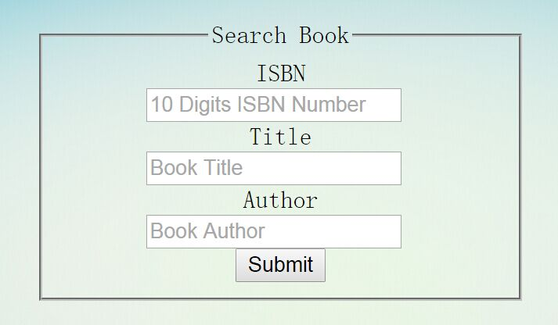

In order to search for a book, given any combination of book_id, title, and/or Author(s), which may be either author_name OR any combination of parts of an author's name. This part supports substring matching. And then display:

* book_id
* title
* author(s)
* branch_id
* How many copies are owned by a specified branch
* Book availability at each branch (i.e. How many copies not already checked out).

The multiple copies at different branch locations will display on separate lines, to facilitate location-specific checkout. ( All authors of a book will be displayed on the same line.)

**2. Check Out Books**

Using this system, you can be able to check out a book, given the combination of ISBN number, branch number and borrower card number.  The date_out could be today’s date. The due_date should be 14 days after the date_out. Each borrower is permitted a maximum of 3 BOOK_LOANS. If a BORROWER already has 3 BOOK_LOANS, then the checkout will fail and return an error message. If there are no more book copies available at your selected library_branch, then the checkout will fail and return an error message.

**3. Return Book**

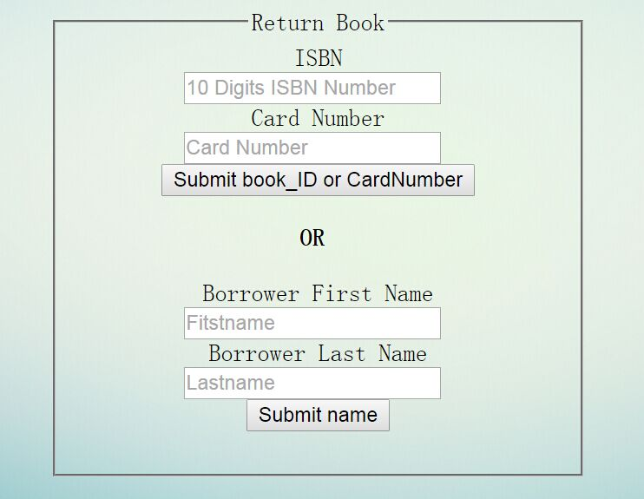

In order to return a book, you can search on any of book ISBN number, Card_no, and/or any part of borrower name. Once located, click a button to check in.

**4. Borrower Management**

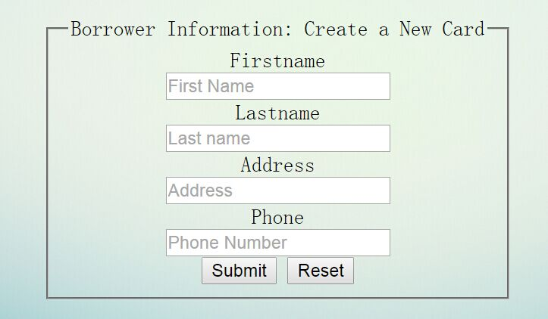 This system is able to create new borrowers. All name and address attributes are required to create a new account. After filling the form, it will automatically generate new card number for each new user. Borrowers are allowed to possess exactly one library card. If a new borrower is attempted withe same first name, last name, and address, then the system will reject and return an error message.

**5. Fine Management**



This is the fine management enter, click it to track or pay for library fines.

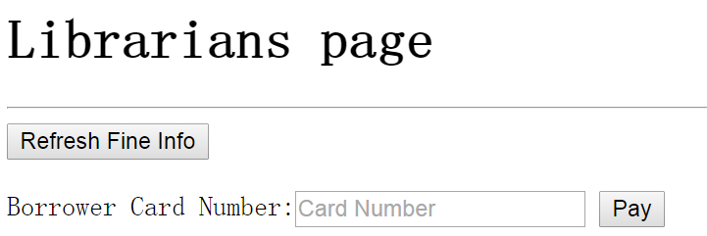

The refresh button updates/refreshes the fines info.

There are two scenarios for late books:

(1) Late books that have been returned — the fine will be [(the difference in days between the due_date and date_in) * $0.25].

(2) Late book that are still out — the *estimated* fine will be [(the difference between the due_date and TODAY) * $0.25].

If a borrower already has fine for a particular late book_loans record, then

It will update the fine amount if different than current value.

The librarians can use the Fines page to pay the fines with entering a card number for that borrower, but do not allow payment of a fine for books that are not yet returned.

**High-level Architecture**

**SQL Schema**

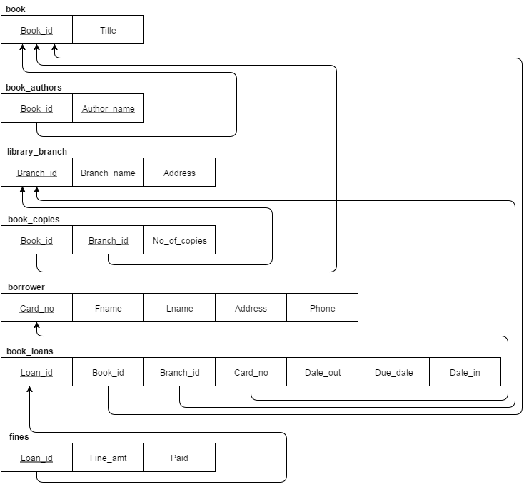

**Technical Dependencies**

HTML5 / CSS

JavaScript

PHP 5

MySQL

Apache